Suggested Email Newsletter Copy
Dear [Name],
In this year’s Union Aid Abroad – APHEDA Global Solidarity Raffle, there are prizes for everyone! For the fitness-freaks, for the globe-trotters, and for the book-worms! 🚴✈️📚
The Union Aid Abroad – APHEDA annual raffle raised almost $70,000 last year, and this year [Name of Union] wants to help them beat it!

Union Aid Abroad – APHEDA is the global justice organisation of the Australian union movement, and the fundraising efforts of thousands of union members like you will help strengthen their projects across the globe that build strong unions and powerful social movements.
As well as raising funds for global justice, you’ll go in the draw for some terrific prizes!
[BUTTON] Buy a book of tickets!
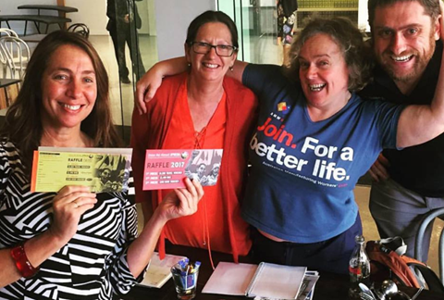
Sam, Jaqueline (ANMF Victoria) Cindy (ASU), and Daniel (ANMF Federal) helped raise funds in last year's raffle!

FIRST PRIZE: Explore the wide world with an $8,000 travel voucher!
SECOND PRIZE: Cruise through the city streets on a sleek Focus bicycle valued at $1,799. The bike looks great, and best of all, it’s so much fun to ride!
THIRD PRIZE: Imagine new worlds and understand our own world with a $500 book voucher from Gleebooks!
BOOK SELLER’S PRIZE: Buy big and sell hard! Every three books of tickets you buy or sell will give you an entry into a special second-draw to win a second Focus bicycle valued at $1,799!

To go in the running, you can either buy your tickets online or complete this form. Alternatively, give us a FREECALL at 1800 888 674 or email office@apheda.org.au
[BUTTON] Buy your tickets today!

